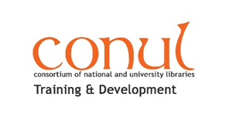
The 2019 Library Assistant Blog award is for an article in the style of a blog post.

Prizes:
1st Prize - €200
2nd Prize - €150
3rd Prize - €100

These posts may subsequently be hosted on a blog by CONUL Training & Development

The 2019 CONUL T&D Library Assistant Blog Award
Closing Date 15 May 2019 20192019

Name:

Position:

Library:

Address:

Tel:

Email:

Blog Title:

Blog word count (excluding links and references):

Permission to publish to LibFocus:
In the event that my entry is a winning or highly commended entry I grant permission to CONUL Training & Development and LibFocus to post my entry to http://www.libfocus.com/

I agree I do not agree

Closing date: 5.00pm Wednesday, 15th May 2019. Please email your submission to your local CONUL Training & Development representative http://www.conul.ie/membership-and-roles/ and save your file in the format ConulT&D LA award submission including your name and organisation – eg. ConulT&D LAawardsubmissionDonnaODoibhlinUCC

