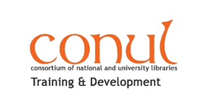
CONUL T & D Library Assistant 2019 Award - Online Resources

Writing support:

• Libfocus: https://www.libfocus.com/

• Academic Writing Librarians: http://academicwritinglibrarian.blogspot.com/

• Writing.ie Guide to Writing a Blog: https://www.writing.ie/resource-types/essentialguides/writing-a-blog/

• How to write a blog people want to read: https://www.success.com/5-tips-to-write-a-blog-post-people-will-actually-read/

• Using visuals to enhance your credibility: https://coolinfographics.com/blog/2016/2/27/using-visuals-to-enhance-your-credibility.html

For some inspiration you might like to read some of the posts from previous CONUL T&D LA Blog winners @ https://www.libfocus.com/2018/06/conul-training-development-library.html and the OEDb top 25 Library BloggersSites: https://oedb.org/ilibrarian/top-25-librarian-bloggers-by-the-numbers/ (links to the blogs are listed at the bottom of the web page)

Other resources to enhance content:

Images:

• Creative Commons http://search.creativecommons.org/
• PhotoPin http://photopin.com/
• Flickr https://www.flickr.com/creativecommons/

Word Clouds:

• Tagxedo http://www.tagxedo.com/
• Wardle http://www.wordle.net/

Infographics:

• https://infogr.am/
• http://www.coolinfographics.com/tools/

