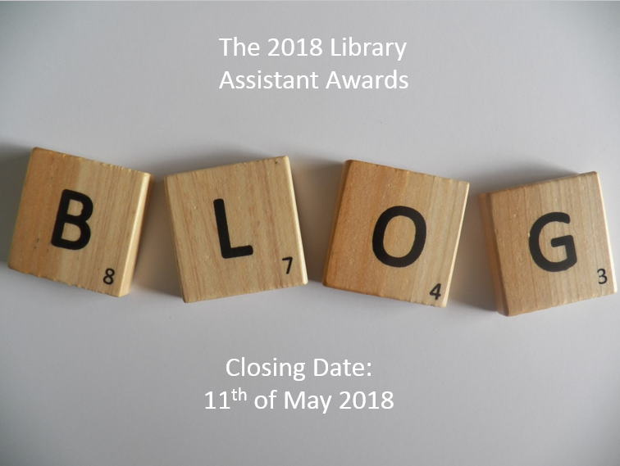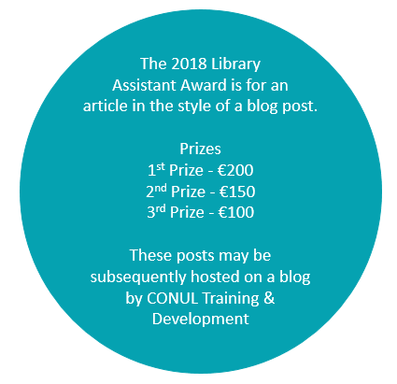
Name:

Position:

Library:

Address:

Tel:

Email:

Blog Title:

Blog word count (excluding links and references):

Permission to publish to LibFocus:
In the event that my entry is a winning or highly commended entry I grant permission to CONUL Training & Development and LibFocus to post my entry to http://www.libfocus.com/

I agree I do not agree

Closing date: 5.00pm Friday, 11th May 2018.

Please email your submission to your local

CONUL Training & Development representative.

