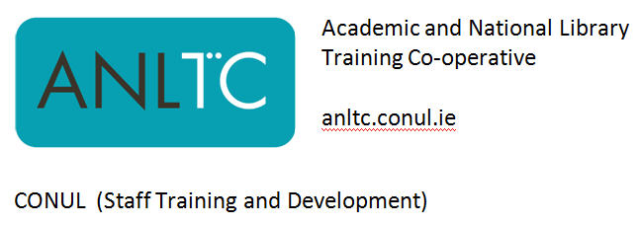
Digital Marketing Toolkit

ANLTC 2016-04
Friday 29th April 2016, Training Room 1, DIT Library, Aungier St., Dublin 2
0930 – 1630

Presenter: | Ned Potter

Programme
(Exact details subject to change to keep the workshop as up to date a possible!)

0930 | Welcome and introduction
0945 | Introduction to Digital Marketing  Publishing Online (including Issuu, Image Sources, Sway)
1115 | COFFEE
1145 | Geolocation  Augmented Reality  Mobile and apps
1300 | LUNCH
1400  1530 | Marketing with Video  Impact and Social Media Part 1: Tumblr and Blogs  BREAK
1545 | Impact and Social Media Part 2: Twitter
1620 | Q & A and Course evaluation

